NYC

Libraries
# install.packages('tidyverse')
library(tidyverse)
── Attaching core tidyverse packages ──────────────────────── tidyverse 2.0.0 ──
✔ dplyr 1.2.1 ✔ readr 2.1.6
✔ forcats 1.0.1 ✔ stringr 1.6.0
✔ ggplot2 4.0.3 ✔ tibble 3.3.1
✔ lubridate 1.9.5 ✔ tidyr 1.3.2
✔ purrr 1.2.1
── Conflicts ────────────────────────────────────────── tidyverse_conflicts() ──
✖ dplyr::filter() masks stats::filter()
✖ dplyr::lag() masks stats::lag()
ℹ Use the conflicted package (<http://conflicted.r-lib.org/>) to force all conflicts to become errors
#install.packages('dplyr')
library(dplyr)
#install.packages('gmodels')
library(gmodels)
#install.packages('readxl')
library(readxl)
#install.packages('lubridate')
library(lubridate)
#install.packages('tableone')
library(tableone)
#install.packages('knitr')
library(knitr)
#install.packages('ggplot2')
library(ggplot2)
#install.packages("patchwork")
library(patchwork)

Dataset
Mutating Date Column
previous_years <- read.csv("previous_years.csv")
edheat2025_live <- read.csv("edheat2025_live.csv")
data2 <- previous_years
data1 <- edheat2025_live
data <- bind_rows(data2, data1)
#Combines data sets with similar rows and columns
data$Date <- as.Date(data$END_DATE)
#Turns end date column into date
data$END_DATE <- NULL

Create Temperature Ranges
data$TEMP_RANGE <- cut(data$MAX_DAILY_TEMP,
breaks = c(-Inf, 60, 80, 90, Inf),
labels = c("Cold", "Warm", "Hot", "Extreme Heat")
)

Descriptive Statistics
# subset(data, as.integer(format(Date, "%Y")) == 2018)
for (i in 2017:2025) {
print(summary(subset(data, as.integer(format(Date, "%Y")) == i)))
}
MAX_DAILY_TEMP HEAT_ED_VISIT_COUNT Date TEMP_RANGE
Min. : 57.00 Min. : 0.000 Min. :2017-05-01 Cold : 1
1st Qu.: 73.00 1st Qu.: 0.000 1st Qu.:2017-06-08 Warm :67
Median : 82.00 Median : 1.000 Median :2017-07-16 Hot :61
Mean : 80.71 Mean : 3.464 Mean :2017-07-16 Extreme Heat:24
3rd Qu.: 88.00 3rd Qu.: 3.000 3rd Qu.:2017-08-23
Max. :102.00 Max. :39.000 Max. :2017-09-30
MAX_DAILY_TEMP HEAT_ED_VISIT_COUNT Date TEMP_RANGE
Min. : 56.00 Min. : 0.000 Min. :2018-05-01 Cold : 1
1st Qu.: 77.00 1st Qu.: 1.000 1st Qu.:2018-06-08 Warm :52
Median : 84.00 Median : 2.000 Median :2018-07-16 Hot :57
Mean : 83.93 Mean : 5.608 Mean :2018-07-16 Extreme Heat:43
3rd Qu.: 91.00 3rd Qu.: 6.000 3rd Qu.:2018-08-23
Max. :103.00 Max. :56.000 Max. :2018-09-30
MAX_DAILY_TEMP HEAT_ED_VISIT_COUNT Date TEMP_RANGE
Min. : 50.00 Min. : 0.000 Min. :2019-05-01 Cold : 5
1st Qu.: 76.00 1st Qu.: 0.000 1st Qu.:2019-06-08 Warm :61
Median : 83.00 Median : 2.000 Median :2019-07-16 Hot :63
Mean : 81.89 Mean : 5.425 Mean :2019-07-16 Extreme Heat:24
3rd Qu.: 89.00 3rd Qu.: 5.000 3rd Qu.:2019-08-23
Max. :107.00 Max. :112.000 Max. :2019-09-30
MAX_DAILY_TEMP HEAT_ED_VISIT_COUNT Date TEMP_RANGE
Min. : 49.00 Min. : 0.000 Min. :2020-05-01 Cold : 2
1st Qu.: 77.00 1st Qu.: 0.000 1st Qu.:2020-06-08 Warm :53
Median : 84.00 Median : 1.000 Median :2020-07-16 Hot :63
Mean : 82.68 Mean : 3.131 Mean :2020-07-16 Extreme Heat:35
3rd Qu.: 90.00 3rd Qu.: 4.000 3rd Qu.:2020-08-23
Max. :100.00 Max. :24.000 Max. :2020-09-30
MAX_DAILY_TEMP HEAT_ED_VISIT_COUNT Date TEMP_RANGE
Min. : 52.00 Min. : 0.000 Min. :2021-05-01 Cold : 4
1st Qu.: 77.00 1st Qu.: 0.000 1st Qu.:2021-06-08 Warm :57
Median : 83.00 Median : 1.000 Median :2021-07-16 Hot :61
Mean : 82.47 Mean : 4.346 Mean :2021-07-16 Extreme Heat:31
3rd Qu.: 88.00 3rd Qu.: 4.000 3rd Qu.:2021-08-23
Max. :104.00 Max. :65.000 Max. :2021-09-30
MAX_DAILY_TEMP HEAT_ED_VISIT_COUNT Date TEMP_RANGE
Min. : 51.00 Min. : 0.000 Min. :2022-05-01 Cold : 4
1st Qu.: 74.00 1st Qu.: 0.000 1st Qu.:2022-06-08 Warm :67
Median : 81.00 Median : 2.000 Median :2022-07-16 Hot :58
Mean : 80.75 Mean : 4.837 Mean :2022-07-16 Extreme Heat:24
3rd Qu.: 88.00 3rd Qu.: 5.000 3rd Qu.:2022-08-23
Max. :101.00 Max. :37.000 Max. :2022-09-30
MAX_DAILY_TEMP HEAT_ED_VISIT_COUNT Date TEMP_RANGE
Min. : 56.0 Min. : 0.000 Min. :2023-05-01 Cold : 4
1st Qu.: 74.0 1st Qu.: 0.000 1st Qu.:2023-06-07 Warm :75
Median : 80.0 Median : 1.000 Median :2023-07-15 Hot :53
Mean : 79.7 Mean : 3.338 Mean :2023-07-15 Extreme Heat:19
3rd Qu.: 85.5 3rd Qu.: 4.000 3rd Qu.:2023-08-21
Max. :101.0 Max. :28.000 Max. :2023-09-28
MAX_DAILY_TEMP HEAT_ED_VISIT_COUNT Date TEMP_RANGE
Min. : 53.00 Min. : 0.000 Min. :2024-05-01 Cold : 5
1st Qu.: 75.00 1st Qu.: 1.000 1st Qu.:2024-06-08 Warm :65
Median : 82.00 Median : 2.000 Median :2024-07-16 Hot :60
Mean : 80.78 Mean : 5.124 Mean :2024-07-16 Extreme Heat:23
3rd Qu.: 86.00 3rd Qu.: 5.000 3rd Qu.:2024-08-23
Max. :100.00 Max. :51.000 Max. :2024-09-30
MAX_DAILY_TEMP HEAT_ED_VISIT_COUNT Date TEMP_RANGE
Min. : 53.00 Min. : 0.000 Min. :2025-05-01 Cold : 3
1st Qu.: 73.00 1st Qu.: 1.000 1st Qu.:2025-06-06 Warm :71
Median : 80.00 Median : 2.000 Median :2025-07-12 Hot :46
Mean : 80.31 Mean : 7.634 Mean :2025-07-12 Extreme Heat:25
3rd Qu.: 88.00 3rd Qu.: 7.000 3rd Qu.:2025-08-19
Max. :103.00 Max. :141.000 Max. :2025-09-29
ds_table <- CreateTableOne(data = data)
Warning in CreateTableOne(data = data): Dropping variable(s) Date due to unsupported class.
kable(print(ds_table, showAllLevels = TRUE, printToggle = FALSE, noSpaces = TRUE))
 | level | Overall
n |  | 1367
MAX_DAILY_TEMP (mean (SD)) |  | 81.48 (9.74)
HEAT_ED_VISIT_COUNT (mean (SD)) |  | 4.75 (9.77)
TEMP_RANGE (%) | Cold | 29 (2.1)
 | Warm | 568 (41.6)
 | Hot | 522 (38.2)
 | Extreme Heat | 248 (18.1)
print(ds_table)
Overall
n 1367
MAX_DAILY_TEMP (mean (SD)) 81.48 (9.74)
HEAT_ED_VISIT_COUNT (mean (SD)) 4.75 (9.77)
TEMP_RANGE (%)
Cold 29 ( 2.1)
Warm 568 (41.6)
Hot 522 (38.2)
Extreme Heat 248 (18.1)

Boxplot
data$Year <- year(data$Date)
ggplot(data,
aes( x = factor(Year), y = MAX_DAILY_TEMP)) +
geom_boxplot(varwidth = TRUE, fill = "red", color = "black") +
labs(
title = "Maximum Daily Temperatures from 2017-2025",
x = "Year",
y = "Maximum Daily Temperature (°F)"
)
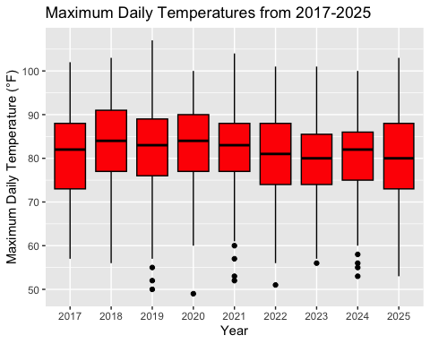
data$Month <- month(data$Date)
may_data <- subset(data, Month == 5)
june_data <- subset(data, Month == 6)
july_data <- subset(data, Month == 7)
august_data <- subset(data, Month == 8)
sept_data <- subset(data, Month == 9)
may <- ggplot(may_data,
aes(y = HEAT_ED_VISIT_COUNT)) +
geom_boxplot(fill = "red", color = "black") +
coord_cartesian(ylim = c(-5, 30)) +
labs(
x = "May",
y = "Heat-Related ED Visits"
) +
theme_minimal()
june <- ggplot(june_data,
aes(y = HEAT_ED_VISIT_COUNT)) +
geom_boxplot(fill = "red", color = "black") +
coord_cartesian(ylim = c(-5, 35)) +
labs(
x = "June",
y = "Heat-Related ED Visits"
) +
theme_minimal()
july <- ggplot(july_data,
aes(y = HEAT_ED_VISIT_COUNT)) +
geom_boxplot(fill = "red", color = "black") +
coord_cartesian(ylim = c(-5, 120)) +
labs(
x = "July",
y = "Heat-Related ED Visits"
) +
theme_minimal()
august <- ggplot(august_data,
aes(y = HEAT_ED_VISIT_COUNT)) +
geom_boxplot(fill = "red", color = "black") +
coord_cartesian(ylim = c(-5, 50)) +
labs(
x = "August",
y = "Heat-Related ED Visits"
) +
theme_minimal()
september <- ggplot(sept_data,
aes(y = HEAT_ED_VISIT_COUNT)) +
geom_boxplot(fill = "red", color = "black") +
coord_cartesian(ylim = c(-5, 30)) +
labs(
x = "September",
y = "Heat-Related ED Visits"
) +
theme_minimal()
p1_final <- wrap_plots(may, june, july, august, september, ncol = 3) +
plot_annotation(
title = "Distribution of Heat-Related ED Visits by Month (2017–2025)",
theme = theme(plot.title = element_text(size = 16, face = "bold"))
) & # <--- This '&' will now successfully apply to EVERY plot in the list
coord_cartesian(ylim = c(0, 15)) &
theme(
axis.text.x = element_blank(),
axis.ticks.x = element_blank()
)
Coordinate system already present.
ℹ Adding new coordinate system, which will replace the existing one.
Coordinate system already present.
ℹ Adding new coordinate system, which will replace the existing one.
Coordinate system already present.
ℹ Adding new coordinate system, which will replace the existing one.
Coordinate system already present.
ℹ Adding new coordinate system, which will replace the existing one.
Coordinate system already present.
ℹ Adding new coordinate system, which will replace the existing one.
print(p1_final)
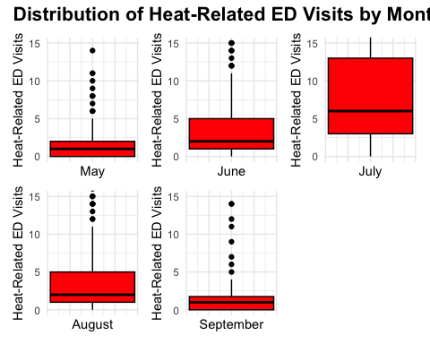
data$Year <- year(data$Date)
ggplot(data,
aes( x = factor(Year), y = HEAT_ED_VISIT_COUNT)) +
geom_boxplot(varwidth = TRUE, fill = "red", color = "black") +
coord_cartesian(ylim = c(0, 15)) +
labs(
x = "Year",
y = "Heat-Related ED Visits",
title = "Distribution of Heat-Related ED Visits by Year" )
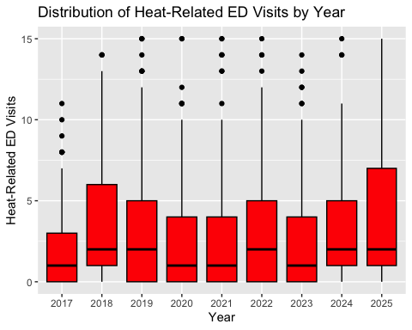

Miscellaneous
#boxplot(HEAT_ED_VISIT_COUNT ~ factor(
# Month,
# levels = c(5, 6, 7, 8, 9),
# labels = c("May", "June", "July", "August", "September")),
# data = data,
# xlab = "Month",
# ylab = "Heat-Related ED Visits",
# main = "Distribution of Heat-Related ED Visits by Month")
#ggplot(data,
# aes(x = HEAT_ED_VISIT_COUNT)) +
# geom_histogram(binwidth = 1,
# fill = "yellow",
# color = "black") +
# labs(
# title = "Distribution of Heat-Related ED Visits (2017–2025)",
# x = "Month",
# y = "Heat-Related ED Visits"
# ) +
# theme_minimal()
#p <- ggplot(data, aes(x = factor(Month), y = HEAT_ED_VISIT_COUNT)) +
# geom_boxplot(fill = "lightblue") +
# labs(
# title = "Heat-Related ED Visits by Month (2017–2025)",
# x = "Month",
# y = "Heat-Related ED Visits"
# ) +
# theme_minimal()
#print(p)
#ggplot(data,
# aes( x = factor(Year), y = HEAT_ED_VISIT_COUNT)) +
# geom_(varwidth = TRUE, fill = "lightblue", color = "black") + coord_cartesian(ylim = c(-10, 75)) +
# labs(
# title = "Maximum Daily Temperatures from 2017-2025",
# x = "Year",
# y = "Heat-related ED Visits",
# main = "Distribution of Heat-related ED Visits by Year"
# )

